**How is Setsubun Festival celebrated?**

In 2020, the Setsubun festival is held on February 3rd and as usual there will be 'mamemaki' activity - a custom that has been handed down since the 14th century (or even earlier). You will have to throw roasted soybeans and recite an exorcism spell. This interesting custom is very much loved andfollowed by young children. To perform the mamemaki ceremony properly, you need to buy a bag of fukumame(lucky beanbags) that are usually sold in most Japanese stores from early January and throw them out the door saying 'Oni wa soto!' (The devil get out!). This is mostly symbolic, attaching 'the devil' to the misfortunes of man.

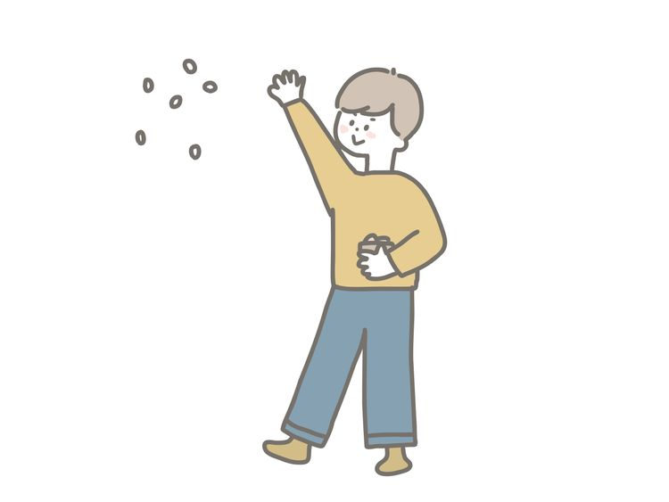

Then you go out and throw roasted soybeans into the house while shouting 'Fuku wa uchi!', which means 'Happy inside!'. According to custom, you will eat a few 'indoor' beans. This is also the reason why people often pack them in plastic bags so that you can comfortably throw and eat the beans that fall on the floor.

style='font-size: 30px;'>**How to celebrate Setsubun (other customs)**

Those are the basic steps to celebrate the Japanese Setsubun festival, but there are many other interesting details. The number of roasted soybeans you eat will correspond to your age, although there are also customs that say you should eat as many beans as your age plus one to prolong your life. Furthermore, in some families the oldest person is the family man or the man in his five years (2020 is the year of the Rat) will pretend to be the devil during the exorcism. This means they have to wear a plastic or paper demon mask (often sold as a set with a fukumame bag) and stand menacingly outside the door and have beans thrown at them. However, holding and dancing the pointed mace to look like a demon is quite dangerous and is often opposed by everyone.

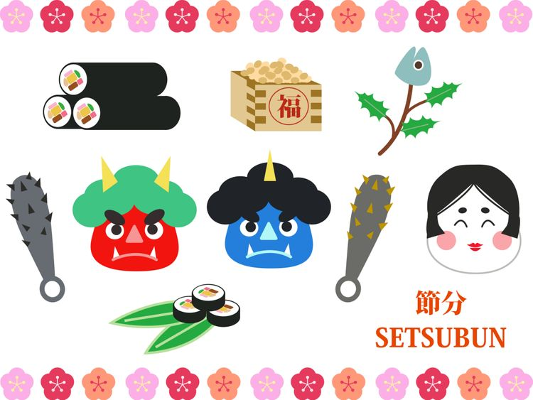

Families in Kanto and Nara still keep their old customs by decorating their houses with fish heads and pointed sacred leaves to ward off evil spirits (because they believe that evil spirits will bring evil spirits). fear the leaves will poke them in the eye). But of course who wouldn't be so afraid, right?

**The Biggest Setsubun Festivals in the Tokyo Area**

Although the Setsubun festival was previously performed at home, over the years it has evolved into a social event and many festivals have been covered in the media, hanging awards and many politicians as well as famous artists, actors or sumo wrestlers attended. One of the biggest events held is the Setsubun festival at Zojo-ji Temple in Tokyo and Naritasan Temple in Chiba Prefecture. At these large temples, more than a ton of roasted soybeans is thrown to the crowds that gather here on the festival day each February.

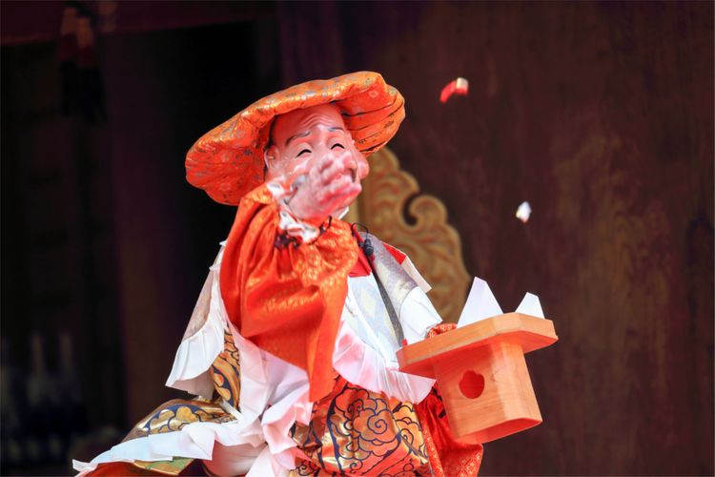

Senso-ji Temple in Asakusa also hosts an equally impressive Setsubun festival, but there's this one that's most special. When the incantations 'Oni wa soto! Fuku wa uchi!' It is said that throughout Japan at this time, at Senso-ji Temple, the largest Buddhist temple dedicated to the Bodhisattva Avalokitesvara, it is believed that demons will never dare to appear before their guardian deity. That's why the spells in Asakusa were changed to 'Senshu banzei fuku wa uchi!' which means 'Eternal good fortune will come!'

**What is Ehomaki?**

Peanuts aren't the only miracle food you might see during the Setsubun festival. Recently, Japanese people have also added ehomaki sushi rolls. Traditionally, ehomaki sushi rolls should be full of seven ingredients that represent Japan's Seven Lucky Gods (Shichifukujin). These ingredients can be anything like: cucumber, omelette (tamagoyaki), roast beef, scallops, etc. The details of each type of material are not so important. The most important thing is that you have to wrap them all together and not cut them after you're done. Normally, people will cut sushi rolls into small pieces but ehomaki is never cut because it is believed that it will mean 'cutting off' your luck.

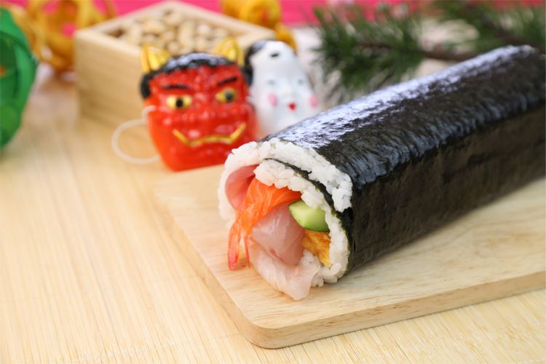

**How to eat Ehomaki?**

You can easily make Ehomaki at home or simply buy it at the store. Either way, you need to know how to eat it properly. Besides not cutting the rice roll, you need to pay attention when eating Ehomaki to sit very quietly and face the lucky direction of the year to pray for the god of luck to come to you.This tradition seems to have originated in the eastern part of Japan around the Edo period (1603-1868) and often changes position every year according to the rotation of the two poles of yin and yang. These mystical cosmic views are based on ancient Chinese philosophy. And rightly so, the 'direction of fortune' ehomaki is changed from year to year. As in 2020, this direction is West - Northwest, so if you want your ehomaki roll to work best during the year, you should bring a compass to measure it accurately!

**Which Setsubun festival is right for you?**

If you have just arrived in Japan in early February, you can attend the Setsubun festival at temples throughout the capital. These festivals are lively and frenetic as everyone is scrambling for the beans, which is an amazing experience you can't find anywhere else. After finishing fighting for the beans, remember to buy ehomaki and eat while facing in the right direction to welcome the god of luck for the whole year!

